#### 21UIT005 AISWARYA SIVAPRASAD S

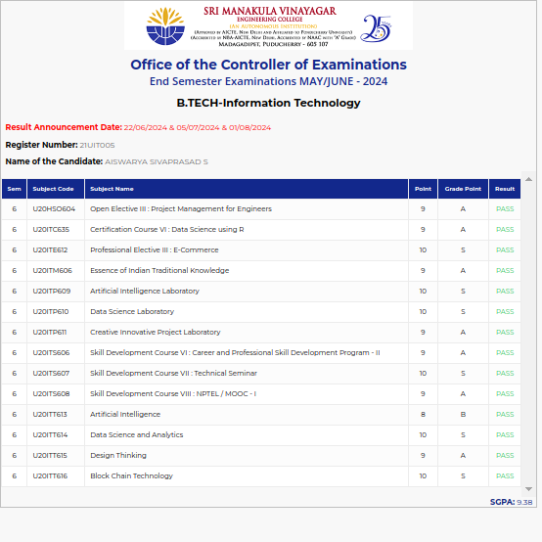

#### 21UIT010 AMARNATH R

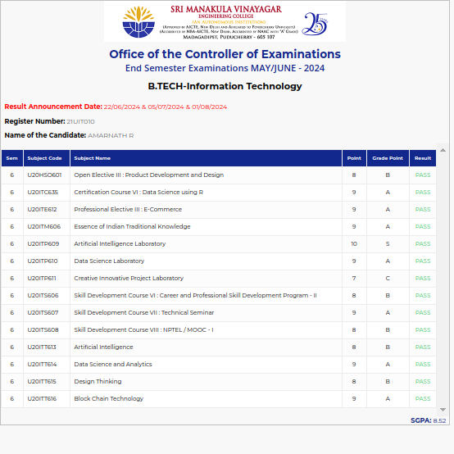

#### 21UIT011 ANANTH K

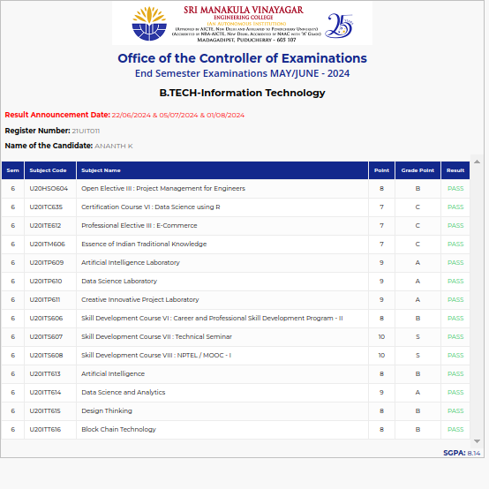

#### 21UIT013 ANUSHA S

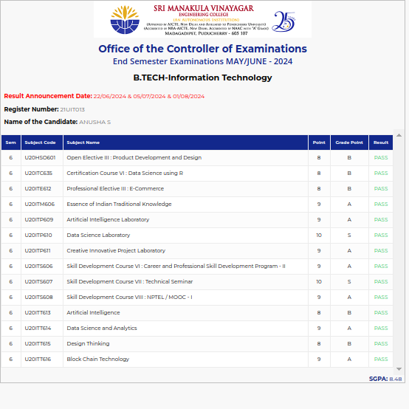

#### 21UIT017 ARUN N

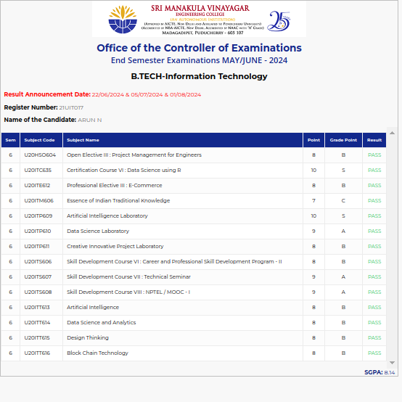

#### 21UIT022 BALAJI S

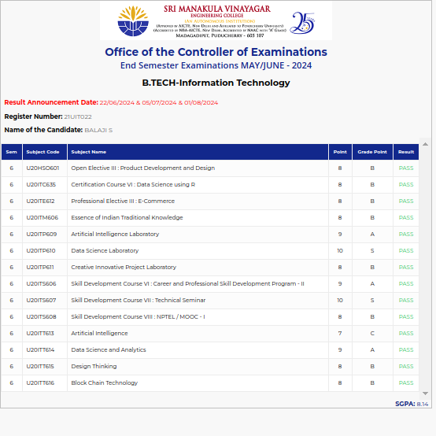

#### 21UIT024 CHARAN M

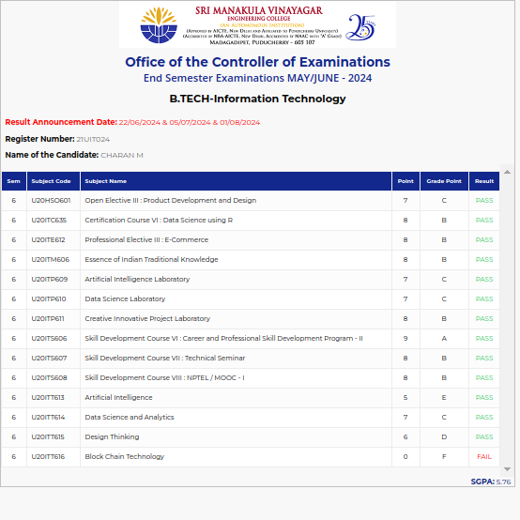

#### 21UIT027 DEEPA S V

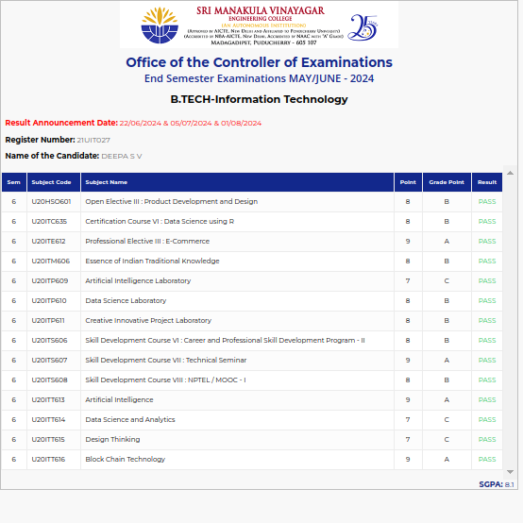

#### 21UIT038 GIREEROOPA J

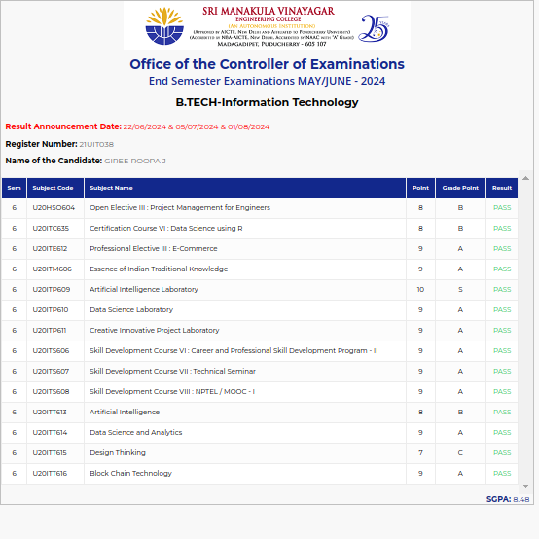

#### 21UIT039 GIRIRAM R

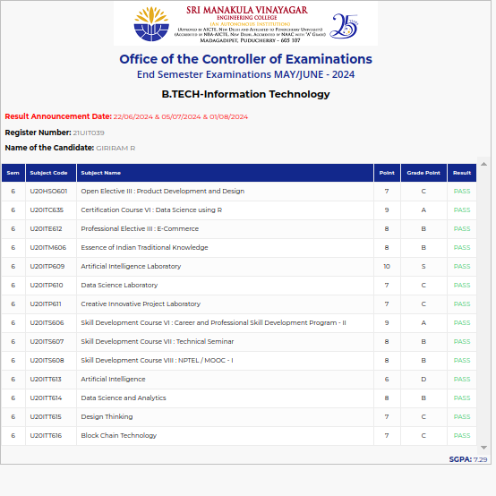

#### 21UIT053 INDHUJA M

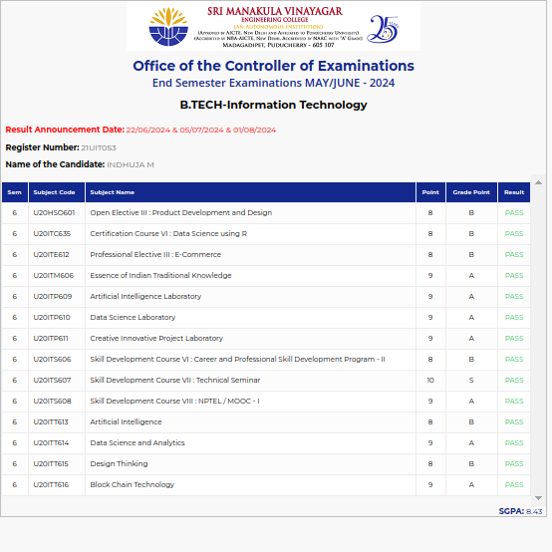

#### 21UIT057 JAYASHRI. P

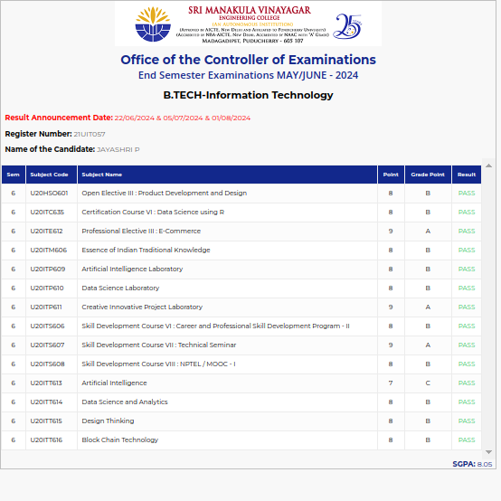

#### 21UIT061 KASTHURI RANGAN R

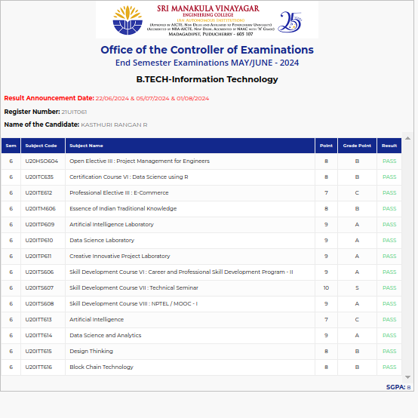

#### 21UIT064 KAVIYA B

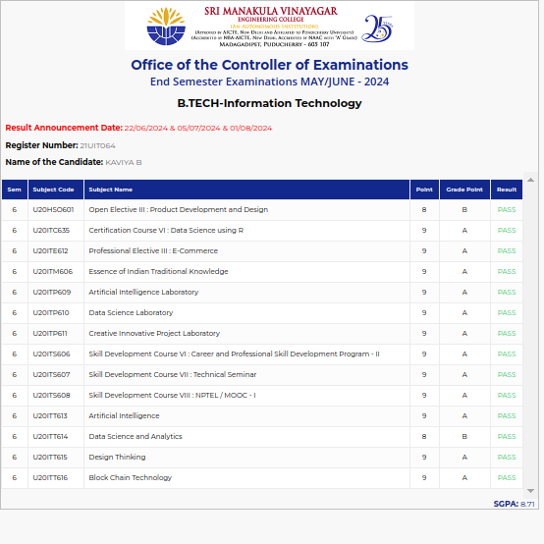

#### 21UIT066 KAVIYAA V

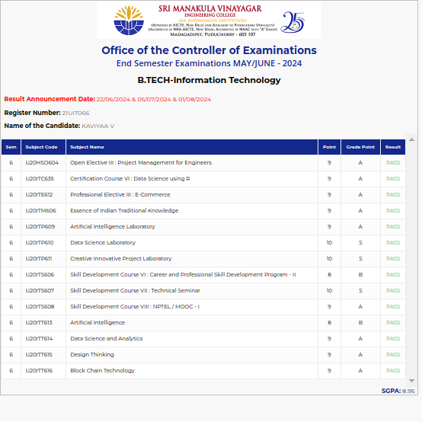

#### 21UIT070 KIRAN KUMAR G

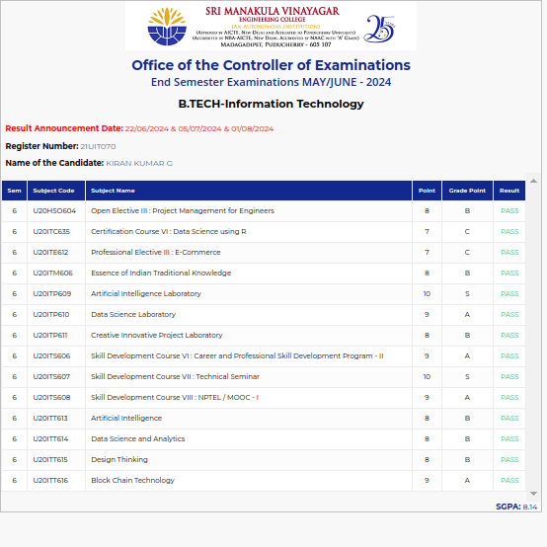

#### 21UIT071 KIRAN.S

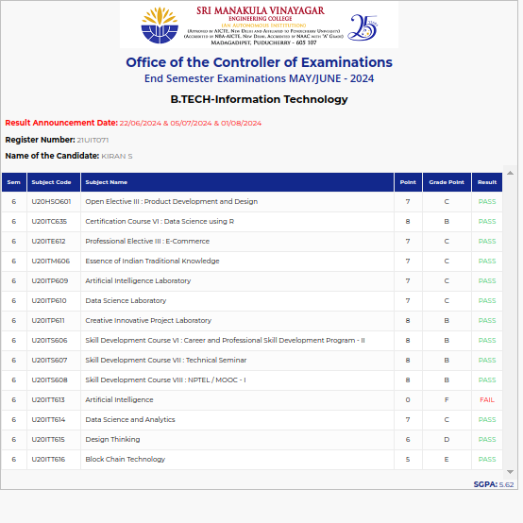

#### 21UIT073 KIRUTHIGA V

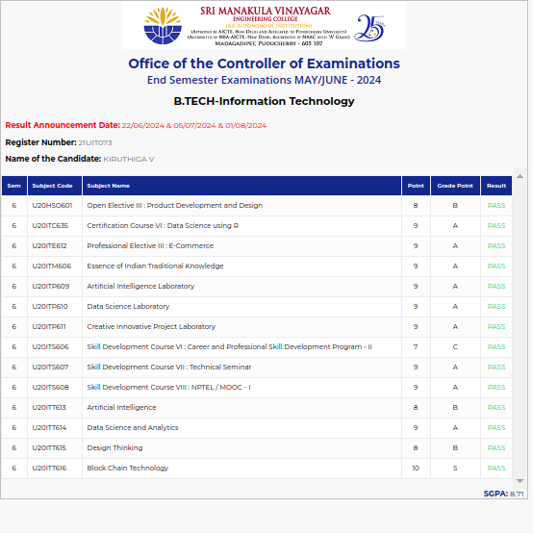

#### 21UIT075 KIRUTHIKA.M

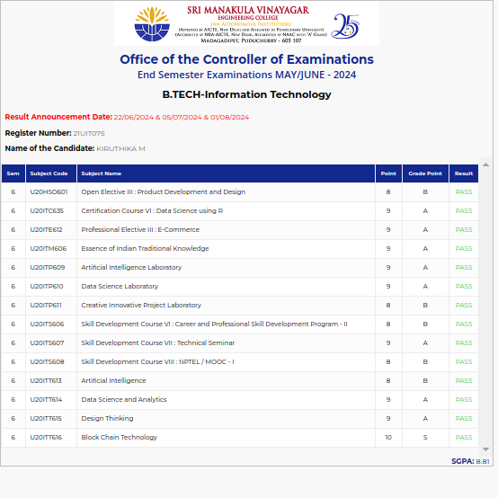

#### 21UIT079 LOGADHARSHINI R

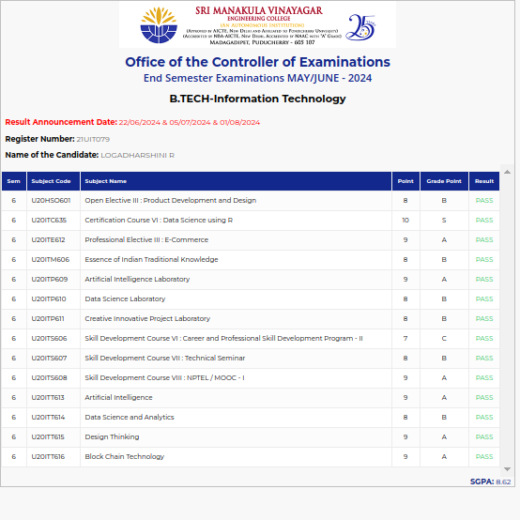

#### 21UIT081 LOGITHA.V

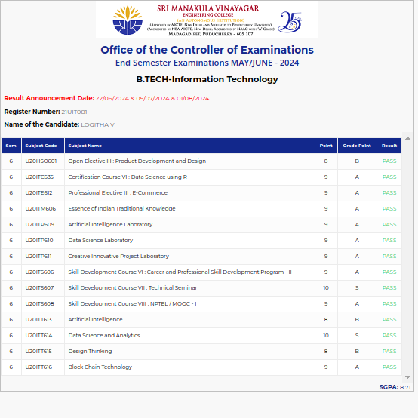

#### 21UIT083 MADHANGI C

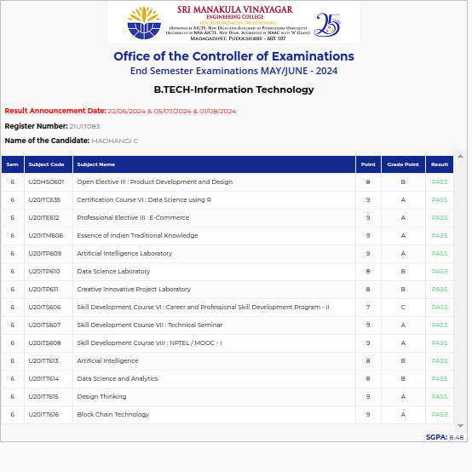

#### 21UIT085 MADHAVAN S

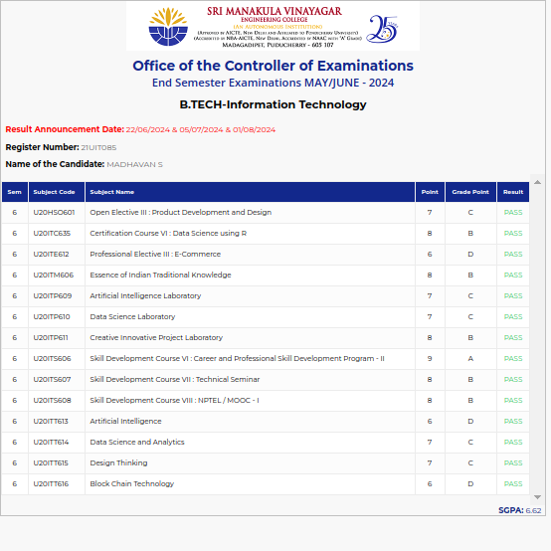

#### 21UIT086 MAHALAKSHMI S

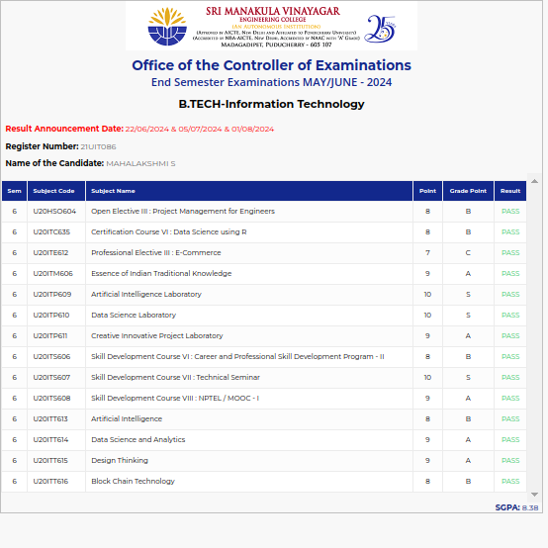

#### 21UIT090 MOHAMMED HANIZ M

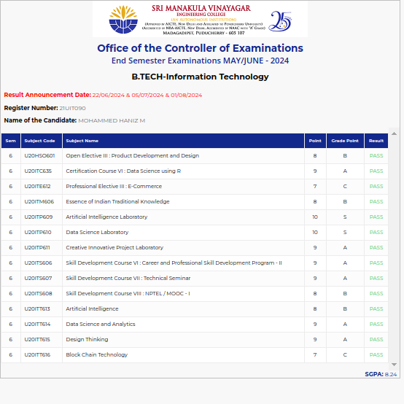

#### 21UIT092 MOHANARAJ.S

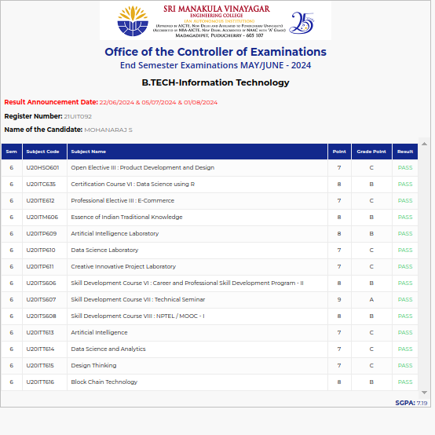

#### 21UIT098 NANTHINI S

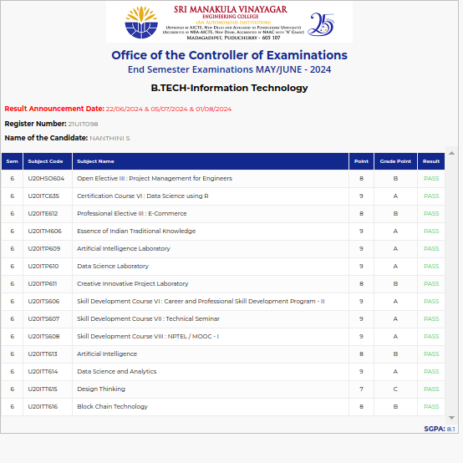

#### 21UIT100 NEELA D

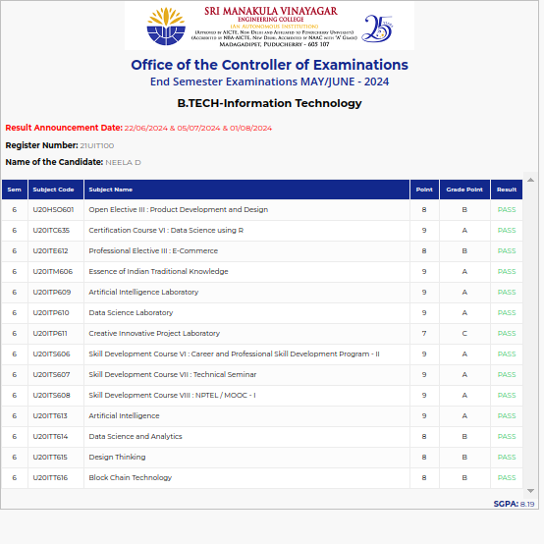

#### 21UIT102 NITHYSHKUMAR G

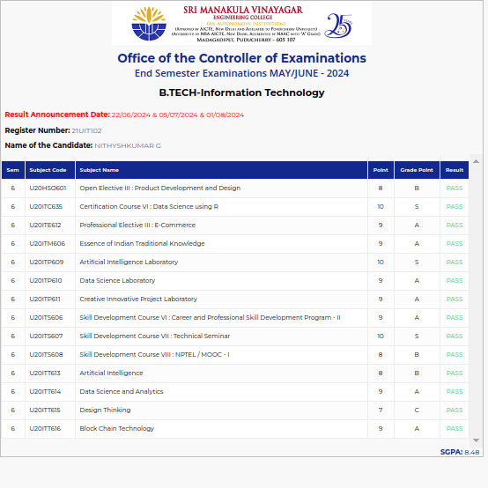

#### 21UIT103 NIVEDHA S

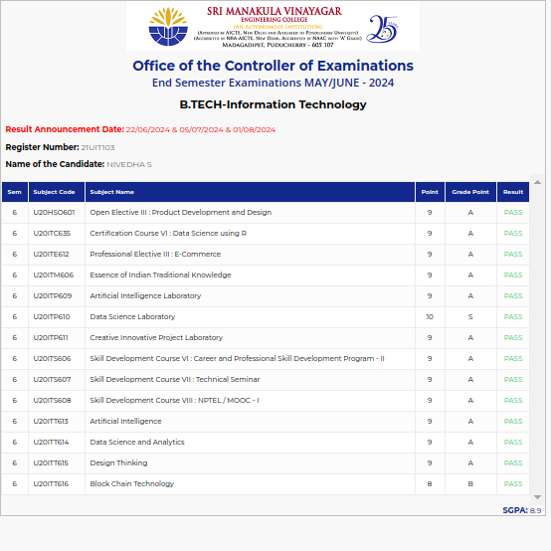

#### 21UIT111 PRAVEENA.V

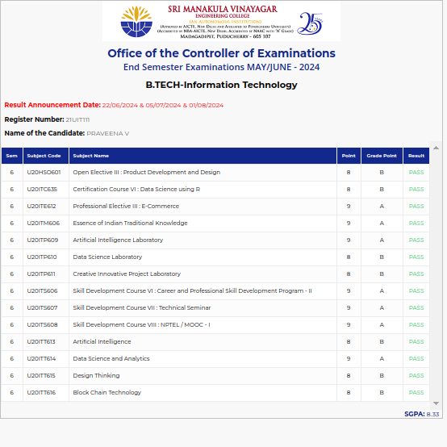

#### 21UIT114 PRETHIKA S

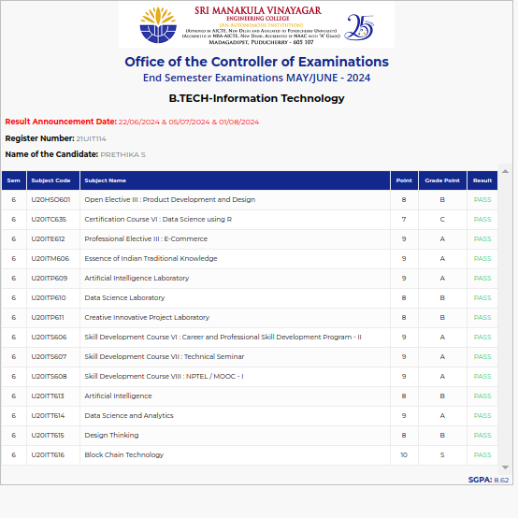

#### 21UIT115 PRISCILLA G

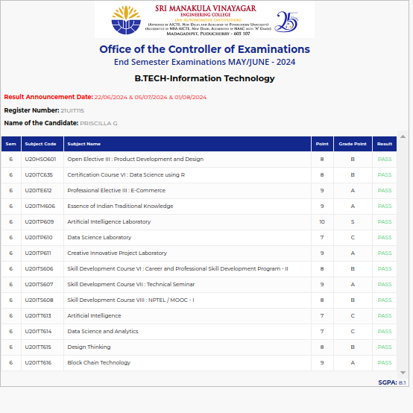

#### 21UIT116 PRITHIVRAJ P

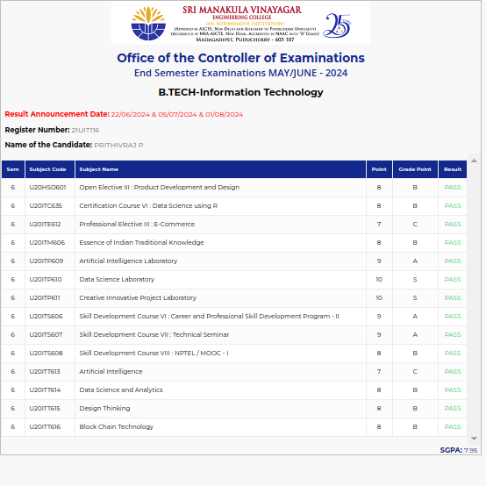

#### 21UIT119 RAGHUL R

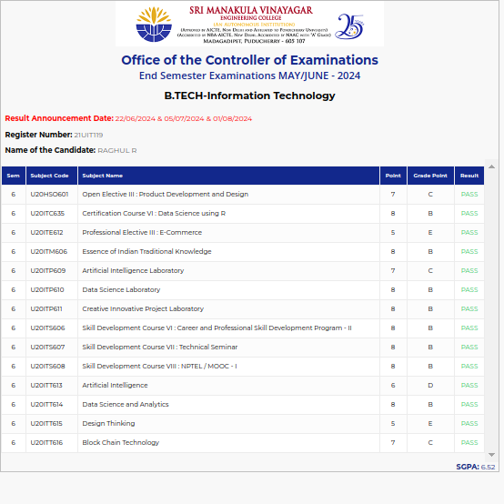

#### 21UIT122 RAGUL S

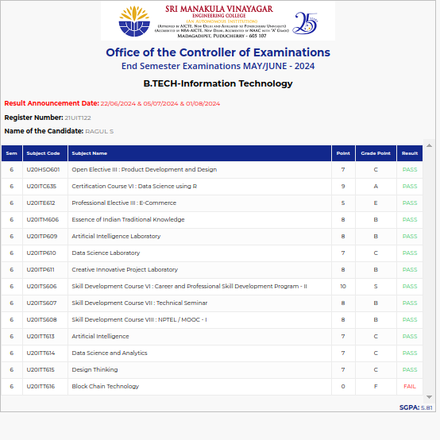

#### 21UIT126 RESHMA A

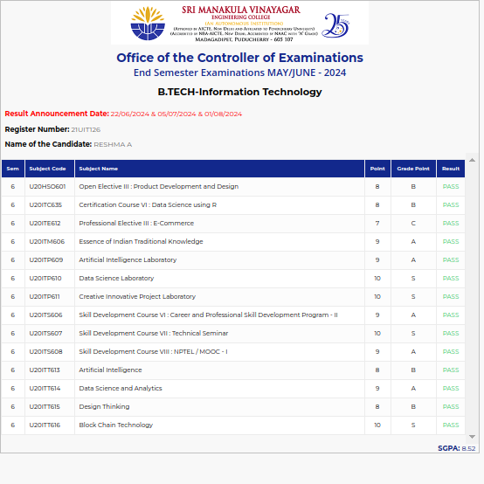

#### 21UIT128 RITHIGA V

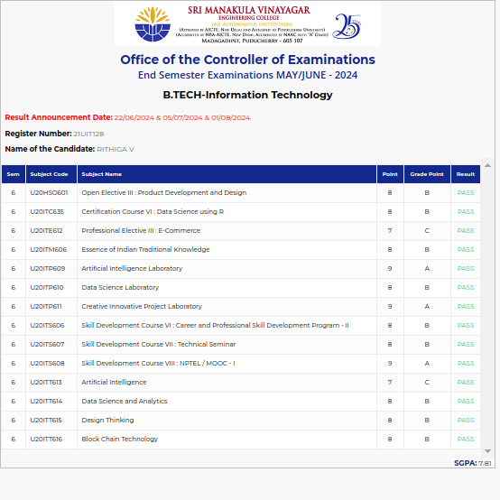

#### 21UIT129 RITHIKAA SHREE M

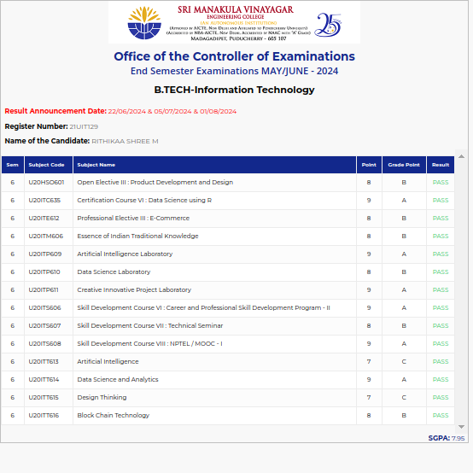

#### 21UIT130 RITHISH R

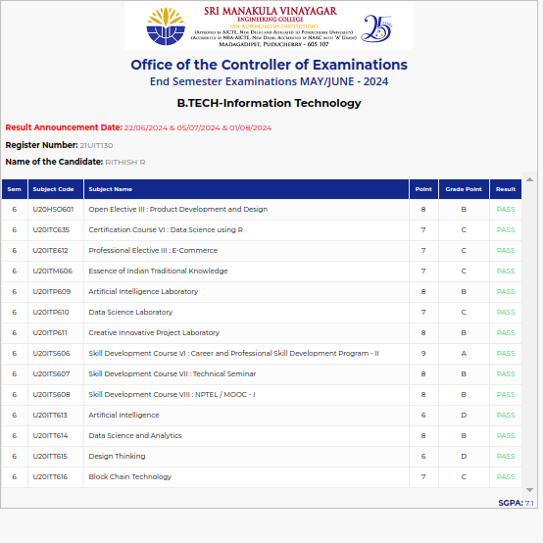

#### 21UIT136 RUBINI S

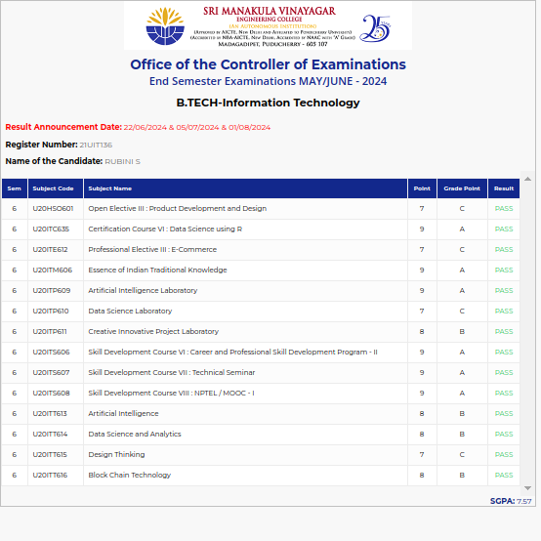

#### 21UIT138 SADHANA D

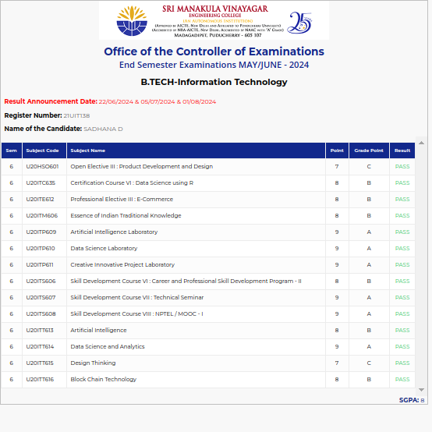

#### 21UIT140 SAKTHISWARRNA T

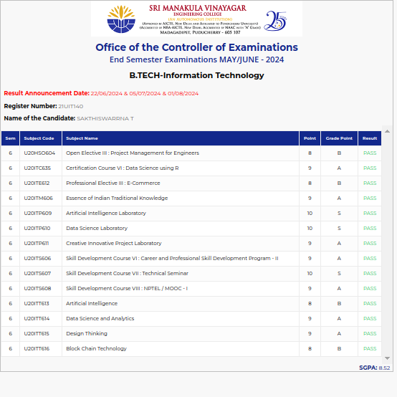

#### 21UIT141 SANGEETHA M

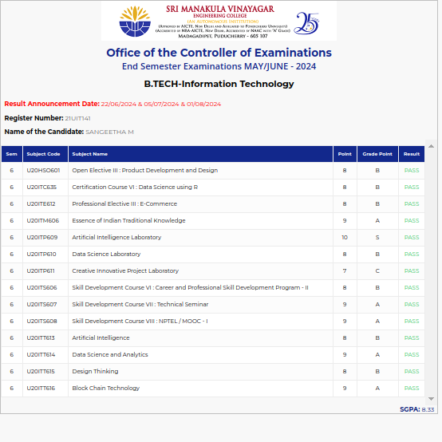

#### 21UIT143 SANJAI M

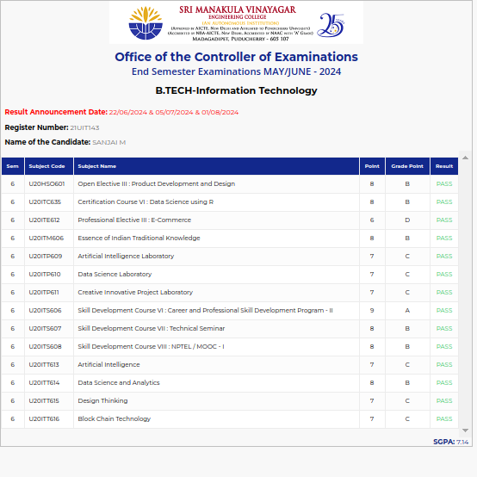

#### 21UIT144 SANJEEVANMUTHU K

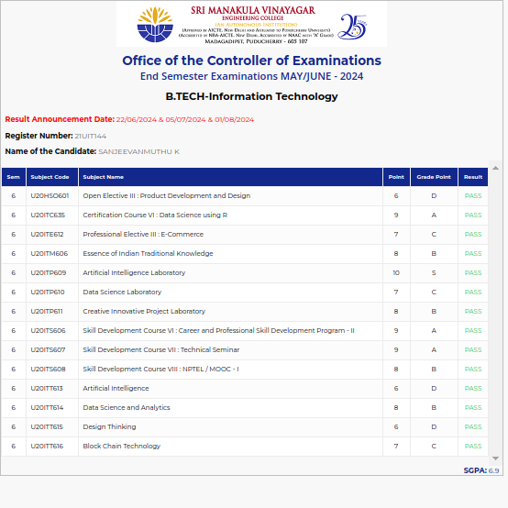

#### 21UIT145 SARANRAJ A

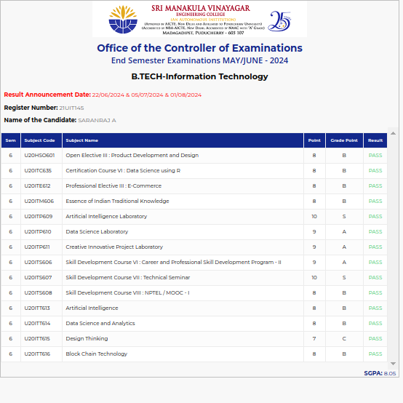

#### 21UIT150 SATHYA.D

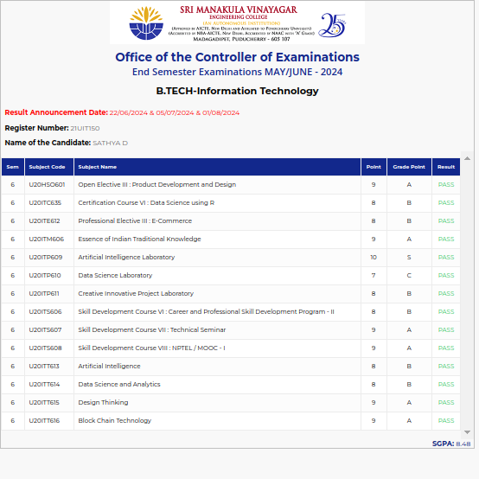

#### 21UIT152 SENKATHIR.T

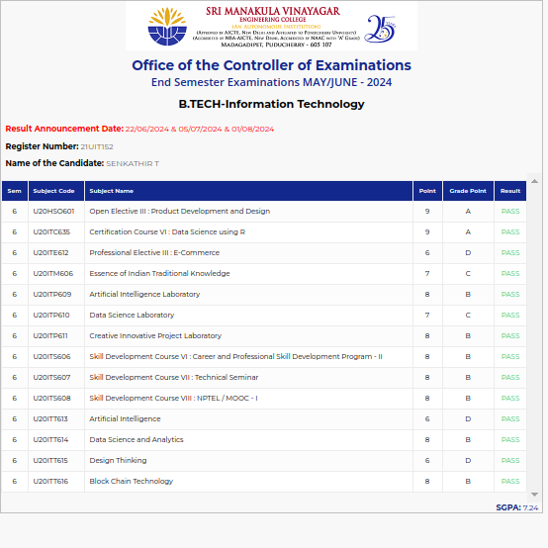

#### 21UIT154 SHIVAPRASSANTH R

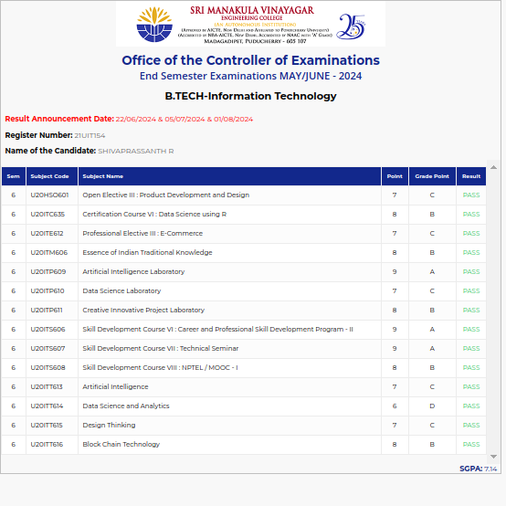

#### 21UIT162 SRIRAM@MURALIDHARAN

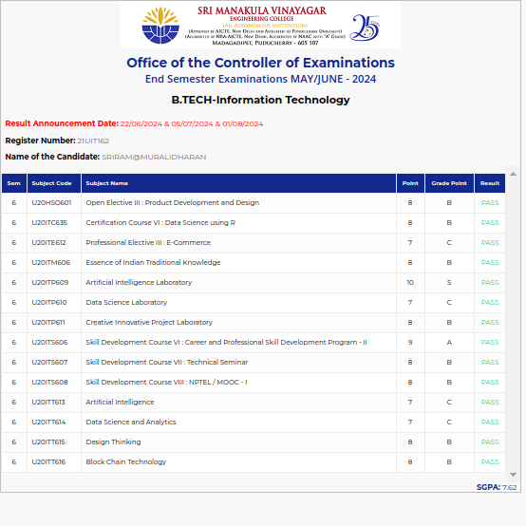

#### 21UIT164 SUGAIL RASHIDH M A

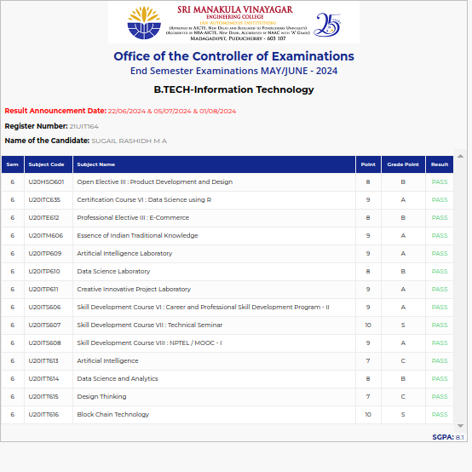

#### 21UIT165 SUNDARAVELA A

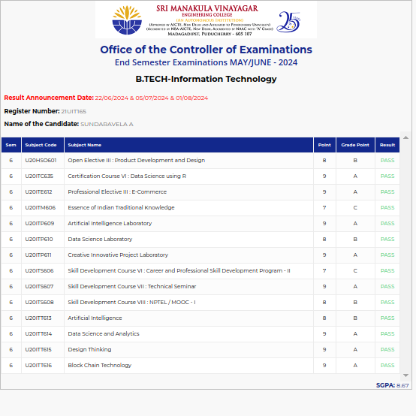

#### 21UIT166 SUNDARESAN RATTINAM A

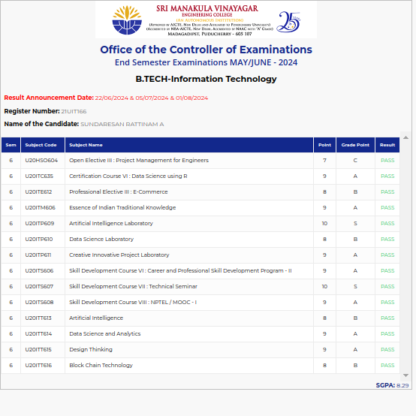

#### 21UIT169 SUVISHA JAN ISWARYA

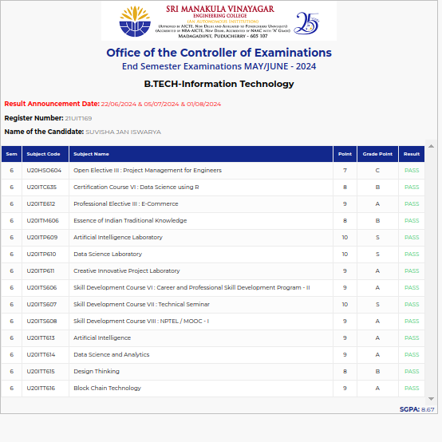

#### 21UIT173 THOUFEEK AHAMED S

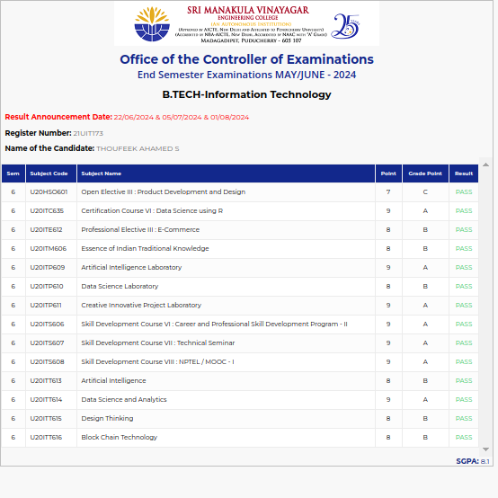

#### 21UIT177 VIKASH S

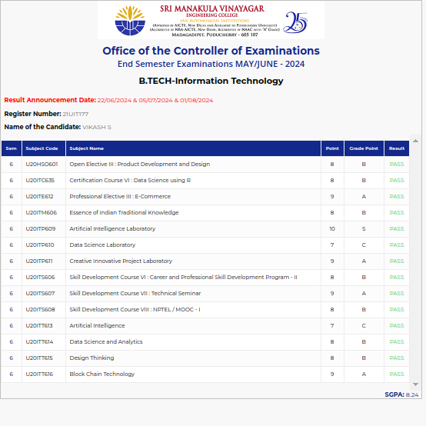

#### 21UIT180 YASHWANTH T

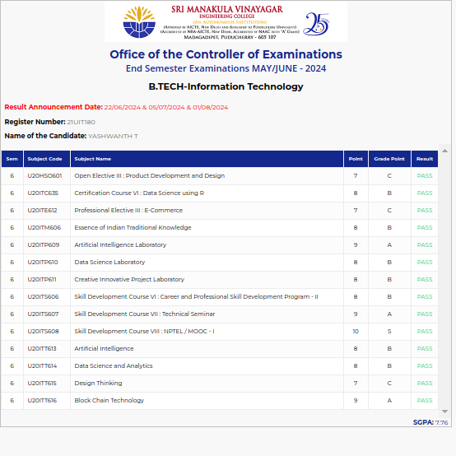

#### 21ITL001 JAYAGANESH S

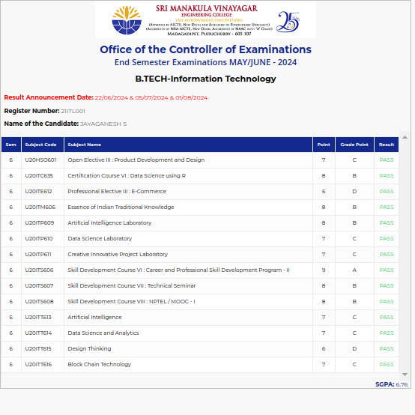

#### 21ITL005 MUTHU M

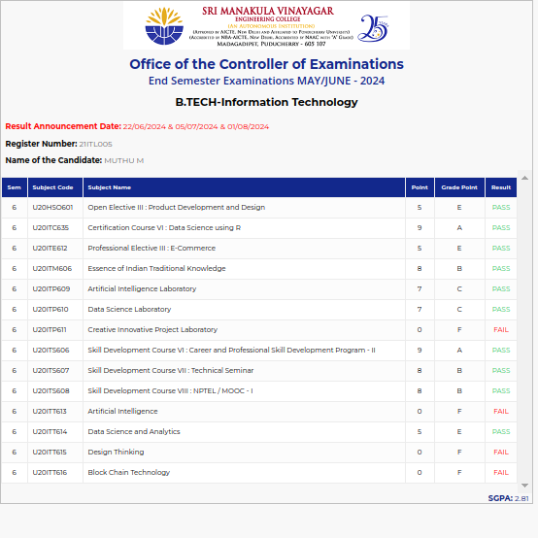

#### 21ITL008 VARUN KUMAR K

